In C#, errors can be categorized into three main types:

syntax errors, runtime errors, logical errors and warning errors.

while syntax errors prevent code from compiling, runtime errors occur during program execution, and logical errors produce unexpected behavior without necessarily causing the program to crash. Identifying and debugging these different types of errors require different approaches such as code inspection, using debugging tools, or handling exceptions appropriately.

**1. Syntax Errors:**

Syntax errors occur when the code violates the rules of the programming language. These errors prevent the code from being compiled or parsed correctly. Common syntax errors include missing semicolons, mismatched parentheses, misspelled keywords, etc.

Example:

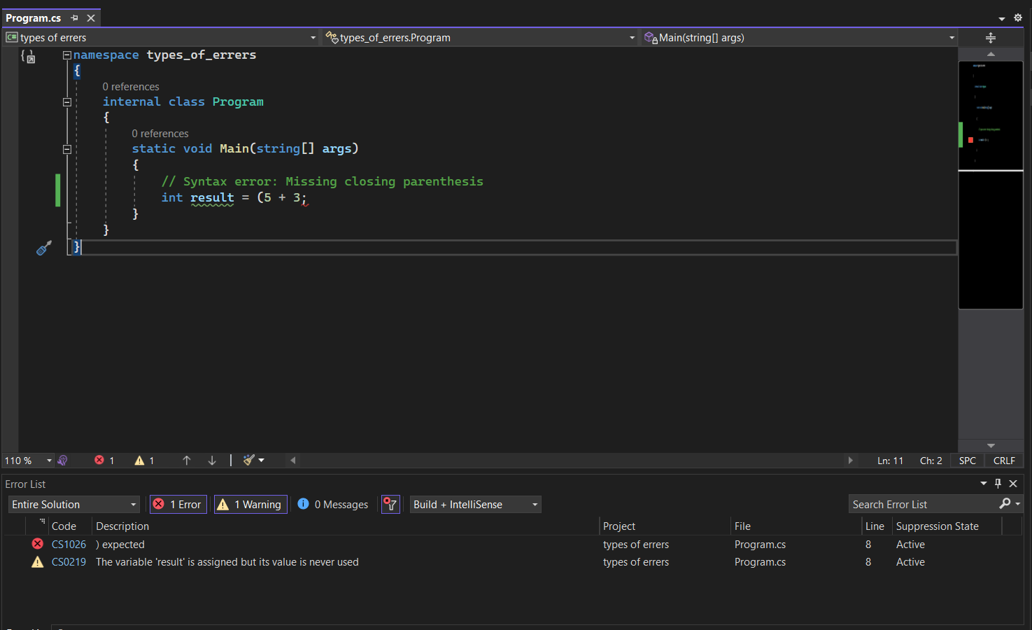

**2. Runtime Errors:**

Runtime errors occur during the execution of a program. They're also known as exceptions and may happen due to issues like invalid user input, division by zero, accessing null references, or attempting to perform unsupported operations.

Example :

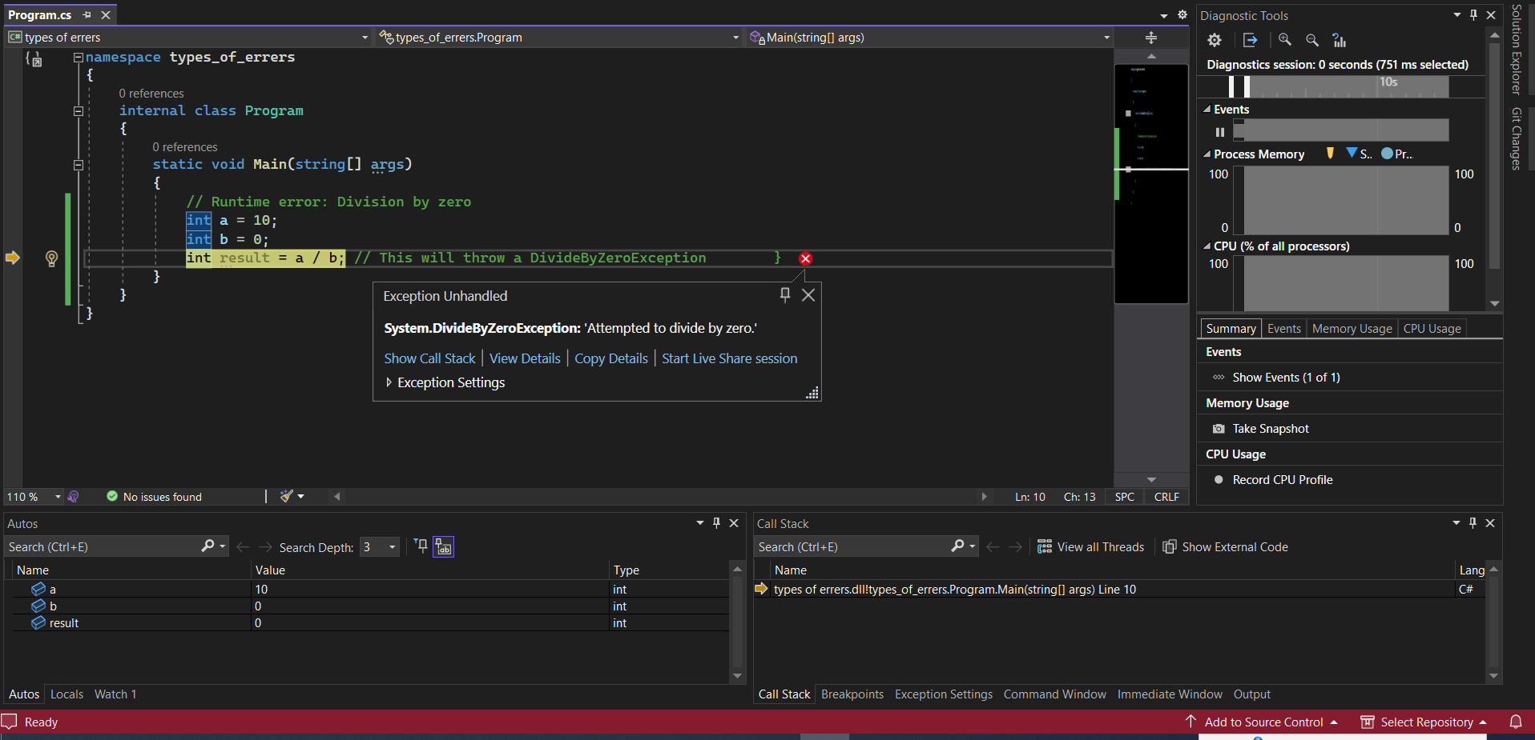

**3. Logical Errors:**

Logical errors occur when the code does not produce the expected output due to incorrect implementation or flawed logic. These errors do not cause the program to crash or throw exceptions but result in undesired behavior or incorrect results.

Example:

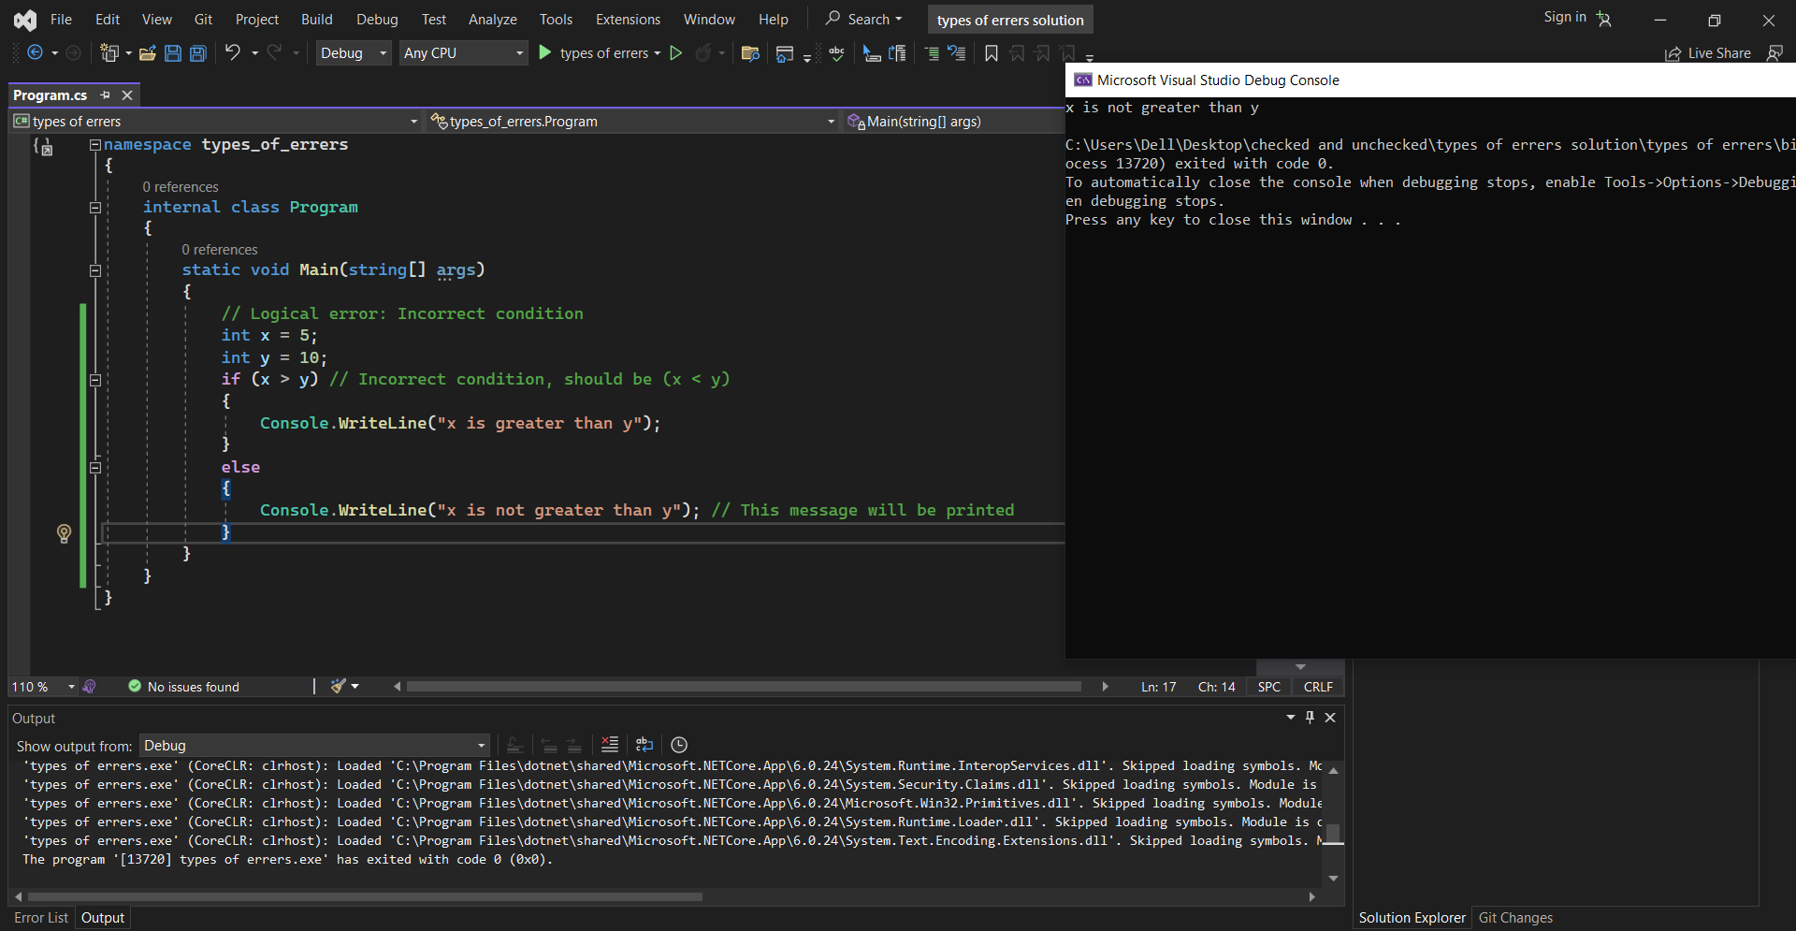

**4.Warning error:**

warning messages are diagnostic messages generated by the compiler to alert developers about potential issues or suspicious code constructs that might cause problems during runtime or produce unexpected behavior. Unlike errors, warnings don't prevent the compilation of code; instead, they highlight areas where improvements or corrections might be needed to ensure better code quality or prevent possible bugs.

Example:



The variable ‘result’ is assigned but its never used.